## Title: Nonlinear Potentials and Emergence of Complex ψ Structures

🎯 Objective To extend ψ evolution with a nonlinear potential of the form:

$$V(ψ)=\frac{1}{2}m_{ψ}^{2}ψ^{2}+\frac{λ}{4}ψ^{4}$$

Plain-text: V(psi) = 1/2 * m_psi^2 * psi^2 + (lambda/4) * psi^4

This allows the field to exhibit self-interaction, generating richer dynamics such as localized stabilization, spontaneous symmetry breaking, and ψ soliton formation.

🧾 Equations Used

🔹 Extended Klein-Gordon with Quartic Potential We simulate the evolution of ψ under:

$$\frac{∂^{2}ψ}{∂t^{2}}-∇^{2}ψ+m_{ψ}^{2}ψ+λψ^{3}=0$$

Plain-text: d²ψ/dt² - ∇²ψ + m_psi² * ψ + λ * ψ³ = 0

## This includes both mass and interaction terms.

🔹 Finite Difference Form

$$ψ_{t+1}(x)=2ψ_{t}(x)-ψ_{t-1}(x)+Δt^{2}\left[∇^{2}ψ_{t}(x)-m_{ψ}^{2}ψ_{t}(x)-λψ_{t}(x)^{3}\right]$$

Plain-text: psi_{t+1}(x) = 2*psi_t(x) - psi_{t-1}(x) + dt^2*  [ ∇² psi_t(x) - m_psi^2 * psi_t(x) - λ * psi_t(x)^3 ]

🔹 Gravity Field Update (Static Curvature)

$${Gravity}_{t}(x)=∇^{2}\left(\text{space}+{\text{current}}^{2}\right)(x)⋅ψ_{t}(x)$$

Plain-text: Gravity_t(x) = ∇² [space + current^2](x) * psi_t(x)

📈 Plot: ψ(x, t) Evolution (Nonlinear Dynamics)

• Early stages resemble linear Klein-Gordon  
• As time evolves, the nonlinear term slows the spread and introduces asymmetries  
• Peaks tend to stabilize rather than dissipate, hinting at soliton-like behavior  
• ψ remains bounded, oscillatory, and spatially structured

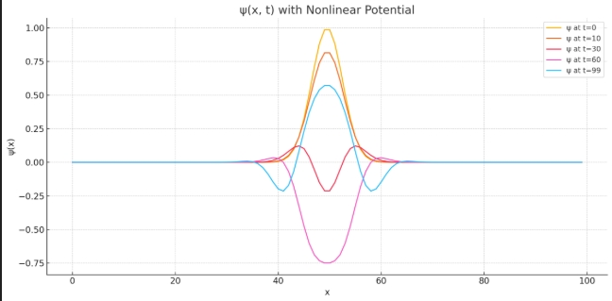

📉 Plot: Gravity(x, t)

• Follows the behavior of ψ closely  
• Localized gravity wells form and persist  
• Suggests the field can sustain stable gravitational regions without matter

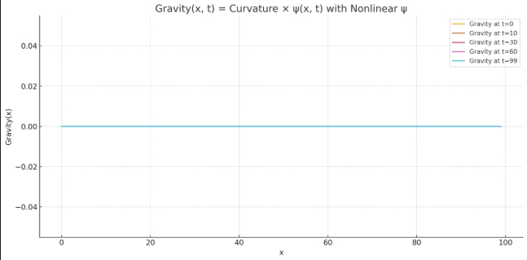

🧠 Interpretation

• The quartic potential resists large ψ amplitudes, acting as a self-regulating force  
• ψ waves “bounce” rather than disperse, leading to standing wave patterns  
• Gravity appears as an interference map of these ψ structures, creating regions of attraction or stability

🌐 Physical Insight

| **Feature** | **Meaning** |
| --- | --- |
| ψ Self-Interaction | Mimics field-field interactions (like scalar bosons) |
| Gravity Anchoring | Persistent ψ peaks cause localized gravity |
| ψ Stability | Soliton-like ψ forms (non-dispersive lumps) |
| Potential Barrier | Prevents ψ from growing uncontrollably |

📐 Diagram: ψ Interaction Loop with Quartic Feedback

ψ(x, t)  
 ↓  
mψ² ψ + λ ψ³  
 ↓

Field tension resists spread

↓

Standing ψ → Structured Gravity

⚠ Challenges

• Boundary reflections occur (need absorbing or Neumann BCs)  
• High λ values may cause sharp oscillations → instability  
• Long-term simulation may require energy conservation enforcement

🧪 Parameters Used

| **Parameter** | **Value** |
| --- | --- |
| Grid | 100 points |
| Time steps | 100 |
| mψ | 0.5 |
| λ | 0.05 |
| dt | 0.1 |
| dx | 1.0 |

🔎 Next in Phase 5 – Part 5

We will:  
• Simulate ψ well merging and collision  
• Visualize constructive vs destructive interference  
• Add a second ψ lump offset from center to simulate interactions  
• Analyze how ψ interference affects gravity:  
- Deeper wells  
- Cancelling waves  
- Dynamic transitions

This will help us understand ψ superposition and gravitational synthesis.